1. **VL with Quadratic Regression: data length, regression error, non-selt match threshold, k, alpaha, anomalies, time**

(0-15000), 35000000, 500, 1, 2,(11396-12760), 00:00:30

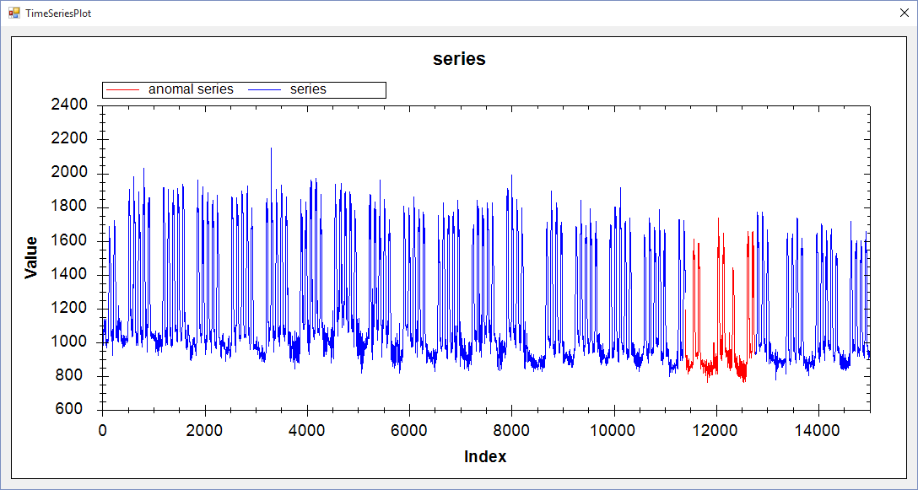

(0-15000), 35000000, 500, 1, 2.2,(11396-12056), 00:00:30

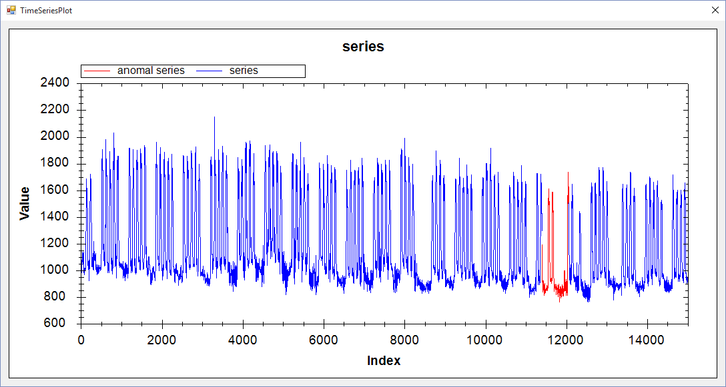

1. **VL with Extrem point: data length, ration, min length,k, alpaha anomalies, time**

(0-15000), 1.7, 180, 1, 1.7, (11277-12544), 00:03:23

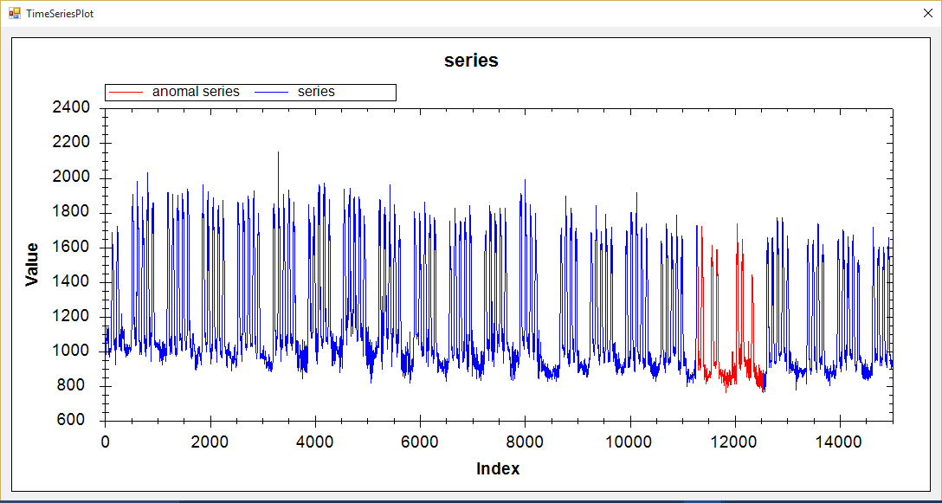

1. **Hot Sax: data length, anomaly length, paa length, discord begin point, time**

(0-15000), 750, 75, 11393, 00:08:33

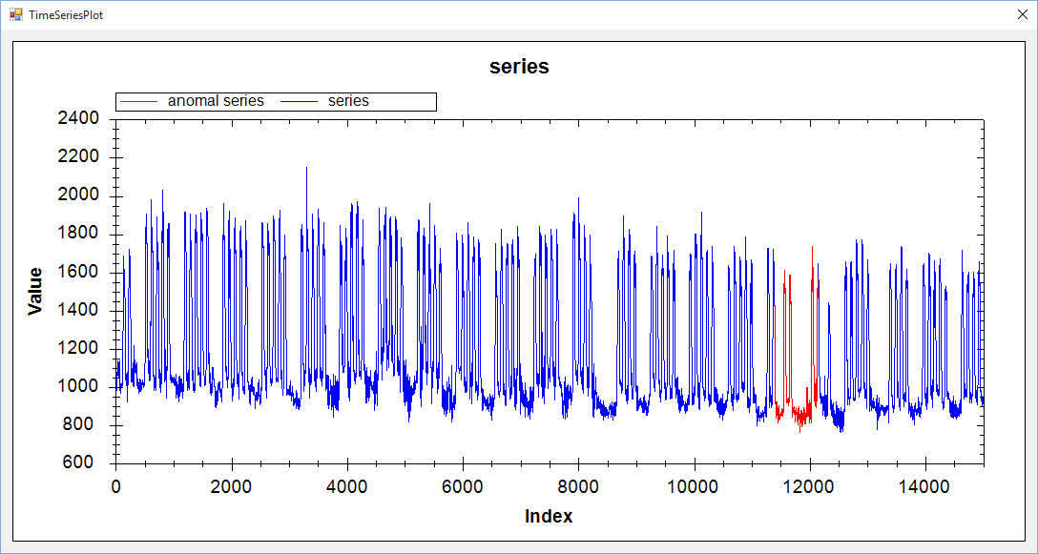

(0-15000), 1000, 100, 11399, 00:07:02

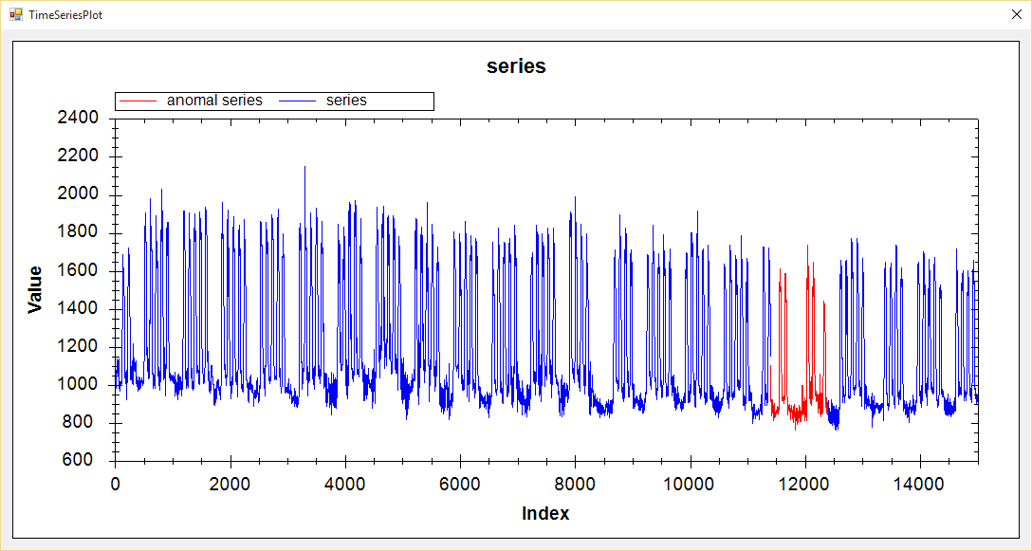

(0-15000), 1200, 120, 11412, 00:07:02

